SeaDream

Sustainable Marine Energy and Ecosystem Resilience Advancement through Digital Technologies and Real-Time Crisis Management

Secondment Report

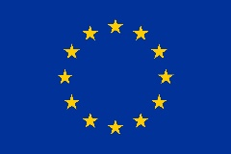 | Funded by the European Union’s Horizon Europe research and innovation programme under the Marie Skłodowska‑Curie Staff Exchange grant agreement No 101182847

PROJECT
Project number: | 101182847
Project acronym: | SeaDream
Project name: | Sustainable Marine Energy and Ecosystem Resilience Advancement through Digital Technologies and Real-Time Crisis Management
Researcher/Admin Staff name
Sending Institution
Host Institution
Dates of Secondment
Duration Secondment
Work Package

Description of the Activities Carried Out during the secondment
In this section you can describe the research or training activities, methods/approaches used, collaboration with host team (meetings, labs, data collection, etc.)

Outcomes & Achievements
In this section you can describe the key results obtained (data, analysis, models, etc.), skills gained (technical, transferable, interdisciplinary), networking and collaborations established, contribution to project deliverables or milestones

Dissemination, Exploitation and Communication activities
In this section you can also list the publications related to your secondment

Challenges & Lessons Learned

